Design Pattern Lab

(20CP210P)

Assignment 5



Name : Kartikey Vaghasiya

RollNum: 21BCP141

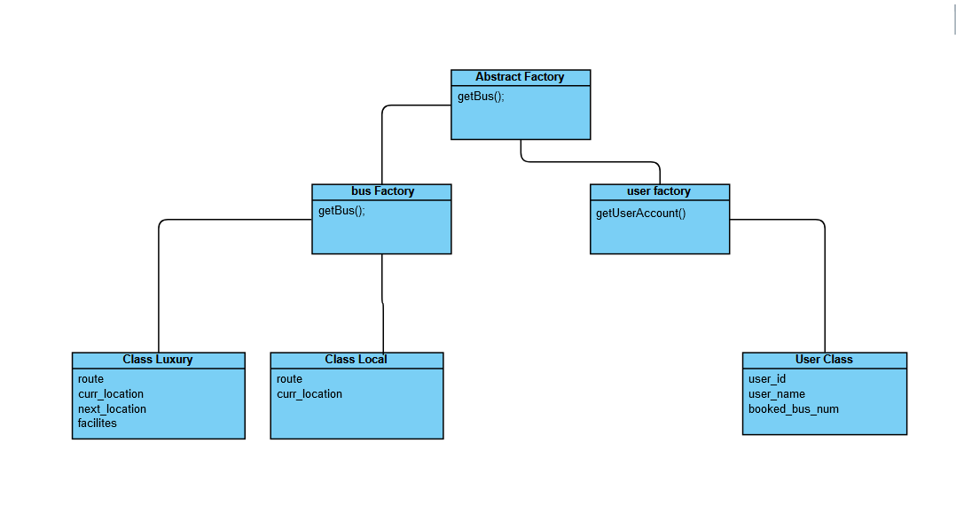

* Class Main

import java.util.Scanner;  
  
public class Main {  
 public static void main(String[] args) {  
  
 // Welcome Messages  
 System.*out*.println("Welcome TO KV Bus Service Portal");  
 System.*out*.println("Please Create Your Account , Enter your name : ");  
  
 // Inputing for Username  
 Scanner userNameInput = new Scanner(System.*in*);  
 String userName = userNameInput.nextLine();  
  
 // Using factory 's factory to get new User  
 User user = new FactoryFactory().getFactory("user").getUser(userName);  
  
  
 Bus local = null;  
 Bus luxury = null;  
  
 boolean cFlag = false;  
  
 do {  
  
 // Which bus user want to book  
 System.*out*.println("Booking Choices : Local(1) or Luxury(2) ");  
 int flag = -1;  
 Scanner sc = new Scanner(System.*in*);  
 flag = sc.nextInt();  
  
 // For booking Luxury bus  
 if (flag == 1) {  
 FactoryFactory ff = new FactoryFactory();  
 Factory bf = (busFactory) ff.getFactory("bus");  
 local = (Bus) bf.getBus("local");  
  
 System.*out*.println("Bus booked Successfully");  
 user.bookedBusType += "local";  
  
 // print details of bus , user  
 System.*out*.println(" 1) User Details 2) Bus Details");  
 Scanner getDetailsInput = new Scanner(System.*in*);  
 int getDetails = getDetailsInput.nextInt();  
  
 if (getDetails == 1) {  
 user.getInfo();  
 } else if (getDetails == 2) {  
 local.getDetails();  
 }  
  
 }  
  
 // For booking Local bus  
 else if (flag == 2) {  
 FactoryFactory ff = new FactoryFactory();  
 Factory bf = (busFactory) ff.getFactory("bus");  
 luxury = (Bus) bf.getBus("luxury");  
  
 System.*out*.println("Bus booked Successfully");  
 user.bookedBusType += " luxury ";  
  
 // print details of bus , user  
 System.*out*.println(" 1) User Details 2) Bus Details");  
 Scanner getDetailsInput = new Scanner(System.*in*);  
 int getDetails = getDetailsInput.nextInt();  
  
 if (getDetails == 1) {  
 user.getInfo();  
 } else if (getDetails == 2) {  
 luxury.getDetails();  
 }  
 }  
  
 else {  
  
 }  
  
 // For running KV bus portal again and again  
 System.*out*.println(" 0 for close application 1 for continue ");  
 Scanner cFlagg = new Scanner(System.*in*);  
  
 int cFlaggg = cFlagg.nextInt();  
  
 if ( cFlaggg == 1 ) {  
 cFlag = true;  
 }  
 else {  
 cFlag = false;  
 }  
  
 } while ( cFlag == true );  
 }  
}

* Interface Factory
* interface Factory {  
   public Bus getBus( String str );  
   public User getUser( String str );  
  }
* Class FactoryFactory ( Factory generator )
* public class FactoryFactory {  
    
    
   public Factory getFactory( String str ) {  
   if ( str == "bus") {  
   return (Factory) new busFactory();  
   }  
    
   else if ( str == "user") {  
   return (Factory) new userFactory();  
   }  
   return null;  
   }  
  };
* class busFactory

public class busFactory implements Factory {  
  
 public Bus getBus(String str) {  
 if ( str == "local") {  
 return (Bus) new Local();  
 }  
 else if ( str == "luxury") {  
 return (Bus) new Luxury();  
 }  
 else {  
 System.*out*.println("Enter Valid Object Name ");  
 return null;  
 }  
 }  
  
 public User getUser(String str){  
 return (User) null;  
 }  
  
}

* class userFactory
* public class userFactory implements Factory {  
   public User getUser(String username) {  
   return (User) new User(username);  
   }  
    
   public Bus getBus(String str) {  
   return null;  
   }  
    
    
  }
* Interface Bus
* interface Bus {  
   String *busNumber* = null;  
   public void updateLocation(String str);  
   public void getDetails();  
  };
* class Luxury
* class Luxury implements Bus {  
   public String busNumber = "lux";  
   static int *busCount* = 0;  
   // for updating bus number whenever new local bus object create  
   Luxury(){  
   busNumber = busNumber + *busCount*;  
   *busCount*++;  
   }  
   private String route[] = new String[]{"Dhoraji", "Jetpur","Rajkot","Ahmedabad","Gandhinagar"};  
   private String busSrc = route[0];  
   private String busDestination = route[ route.length - 1 ];  
   private int currLocationIndex = 0;  
    
   public void updateLocation(String str){  
   if ( str == "update") {  
   currLocationIndex += 1;  
   System.*out*.println ("Updated Successfully ! Current Location is : " + route[currLocationIndex]);  
   }  
   else if ( str == "reset" ) {  
   currLocationIndex = 0;  
   System.*out*.println ("reseted Successfully ! Current Location is : " + route[currLocationIndex]);  
   }  
    
   else {  
   System.*out*.println("Enter valid operation");  
   }  
   }  
    
   public void getDetails() {  
   System.*out*.println();  
   System.*out*.println("Bus : " + busNumber );  
   System.*out*.println("Bus : " + busNumber );  
   System.*out*.println("bus source : " + busSrc );  
   System.*out*.println("bus destination : " + busDestination );  
   System.*out*.println("bus currLocation : " + route[currLocationIndex] );  
   }  
  }
* class Local
* public class Local implements Bus{  
   public String busNumber = "loc";  
   static int *busCount* = 0;  
   // for updating bus number whenever new local bus object create  
   Local(){  
   busNumber = busNumber + *busCount*;  
   *busCount*++;  
   }  
   private String route[] = new String[]{"Dhoraji", "Jetpur","Rajkot","Ahmedabad","Gandhinagar"};  
   private String busSrc = route[0];  
   private String busDestination = route[ route.length - 1 ];  
   private int currLocationIndex = 0;  
    
   public void updateLocation(String str){  
   if ( str == "update") {  
   currLocationIndex += 1;  
   System.*out*.println ("Updated Successfully ! Current Location is : " + route[currLocationIndex]);  
   }  
   else if ( str == "reset" ) {  
   currLocationIndex = 0;  
   System.*out*.println ("reseted Successfully ! Current Location is : " + route[currLocationIndex]);  
   }  
    
   else {  
   System.*out*.println("Enter valid operation");  
   }  
   }  
    
   public void getDetails() {  
   System.*out*.println();  
   System.*out*.println("Bus : " + busNumber );  
   System.*out*.println("Bus : " + busNumber );  
   System.*out*.println("bus source : " + busSrc );  
   System.*out*.println("bus destination : " + busDestination );  
   System.*out*.println("bus currLocation : " + route[currLocationIndex] );  
   }  
  }
* class User
* class User {  
    
   int userId = 0;  
   int staticId = 0;  
   String userName;  
    
   public String bookedBusType = " ";  
    
   public User (){  
   //  
   }  
   public User ( String userName) {  
   this.userName = userName;  
   this.userId = staticId;  
   staticId++;  
   }  
    
   public void getInfo ( ) {  
   System.*out*.println("Name : " + userName);  
   System.*out*.println("Userid : " + userId);  
   System.*out*.println("Booked bus : " + bookedBusType);  
   }  
  }
* Output

